SATAN’S LAMP by WILLIAM JACKSON

Introduced by LINDA HAYDEN

A HAMMER-ESQUE, ROLLERCOASTER RIDE OF A NOVEL SET ON THE NIGHT OF THE DEVASTATING STORM OF 1987.

‘All who turn the pages of Satan’s Lamp - and surrender to the story - will not be disappointed.’ - LINDA HAYDEN
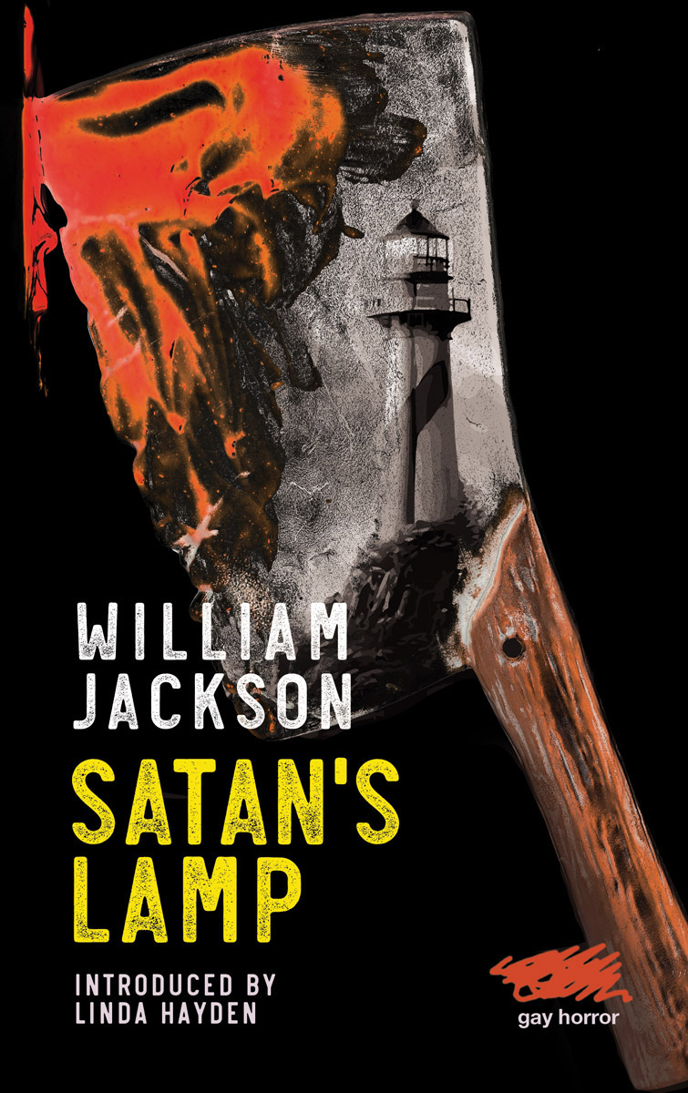
Satan’s Lamp is William Jackson’s debut novel, a gay horror narrative set on a lonely rock lighthouse on the night of the Great Storm of 1987.

Devil’s Rock is the bleakest lighthouse station of all, 15 miles south-west of Cornwall’s Lizard Point. It is a lonely rock believed by superstitious locals to be haunted. That’s why they call it ‘Satan’s Lamp’.

Young Jabe Walker, a rookie keeper, is plagued by nightmares of his abusive father - the father Jabe killed when he was just ten years old.

Now it is the 15th of October 1987 and one of the most violent storms in history is about to strike the English coast. On this night Jabe is forced to confront his violent past.

His father, in all his violent fury, is back from the dead and hell-bent on revenge.

ABOUT WILLIAM JACKSON
William Jackson is the new master of gay horror, striking at the heart of the reader's deepest fears, then deftly twisting his pen. He cites his influences as Richard Laymon, Dennis Wheatley and Fred Mustard Stewart.

ABOUT LINDA HAYDEN Linda Hayden is a British actress, known for her appearances in horror classics of the 1960s and 1970s including ‘Baby Love’ and ‘The Blood on Satan’s Claw’.

Satan’s Lamp is published on 31 March 2023 in an original paperback edition by Martin Firrell Company.

More information and downloadable resources at www.moderneditions.net

Author’s website www.williamjackson.uk

Contact: Rupert Carrington, Publishing Executive, rupert@martinfirrell.com

